Hands On Final Exam

Alex Arnold

Step 1 – System Restore

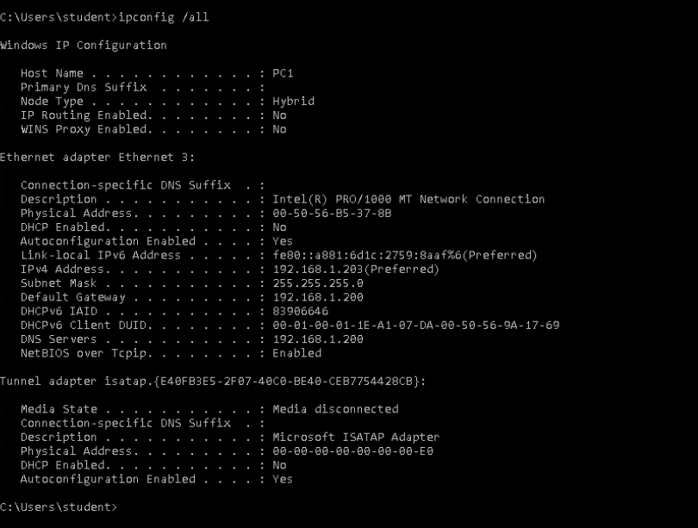

Step 2 –Command

Step 3 – Inbound Rule

Step 4 – Perfmon Counters

Step 5 – Disk Info